Data 226 Lab 1 Report

Matthew Leffler, Daniel Kim

Department of Data Analytics, San Jose State University

1. Problem Statement:

The world of stock trading is an inherently volatile space where market conditions fluctuate rapidly. This unpredictability presents a challenge to investors who strive to forecast daily market movements to optimize their investment strategies. Leveraging machine learning for forecasting can significantly enhance predictability by analyzing historical stock data to project future closing prices.

The development of a data pipeline for this purpose addresses a critical need for continuous and automatic data acquisition. Given that stock prices are constantly changing, a data pipeline enables the systematic collection of stock information without manual intervention. This automation not only ensures that data used for forecasting is current, but also increases the efficiency and accuracy of these predictions.

Therefore, the purpose of this project is to implement a data pipeline that supports real-time data updates and facilitates more reliable stock market forecasts. This approach not only aids investors in making informed decisions but also contributes to a more structured method of navigating stock market volatility.

1. Solution Requirements

To build a robust data pipeline for stock prediction, our workflow is divided into three main stages, each requiring different tools.

1. *Data Extraction and Transformation*

The first stage involves retrieving and transforming stock market data. For this, we will utilize the yfinance API to collect daily stock information. Python will be used to extract this data in the form of a Pandas DataFrame and perform any necessary transformations before storing it. This approach ensures that the data is clean and structured before being stored in a database.

1. *Data Storage and Machine Learning Implementation*

The processed data will be stored in Snowflake, which is well-suited for structured, readily accessible datasets. Unlike traditional databases, Snowflake efficiently handles analytical workloads and does not require storing large raw data files, making it ideal for our use case. Additionally, to securely manage database credentials and API keys, we will be using Apache Airflow to store environment variables. This allows us to protect our account credentials when calling the Snowflake connector and ensures we can use the variables safely throughout the program.

1. *Automation of Data Pipeline*

Running the data pipeline manually daily is inefficient. To automate this process, we will leverage Apache Airflow, which will schedule and manage the data ingestion workflow. Airflow will execute Python scripts to extract data, transform it, and load it into Snowflake via the Snowflake connector. SQL commands will be executed on Snowflake to ensure that the database is updated daily, providing the latest stock data for prediction models.

By integrating Python, Snowflake, and Airflow, this solution ensures a scalable, secure, and automated data pipeline for stock prediction.

1. Functional Analysis:
2. *Connecting to Snowflake*

To establish a functional data pipeline, a secure and automated connection to Snowflake is required. This is achieved using Apache Airflow’s Variables and the snowflake-connector library, which securely store authentication credentials within Airflow’s metadata database and retrieve them dynamically during execution. This approach enhances security by avoiding hardcoded credentials while ensuring efficiency by automating database authentication. The connection serves as the foundation for the pipeline, enabling seamless data extraction, transformation, storage, and automation as part of the overall data ingestion and processing workflow.

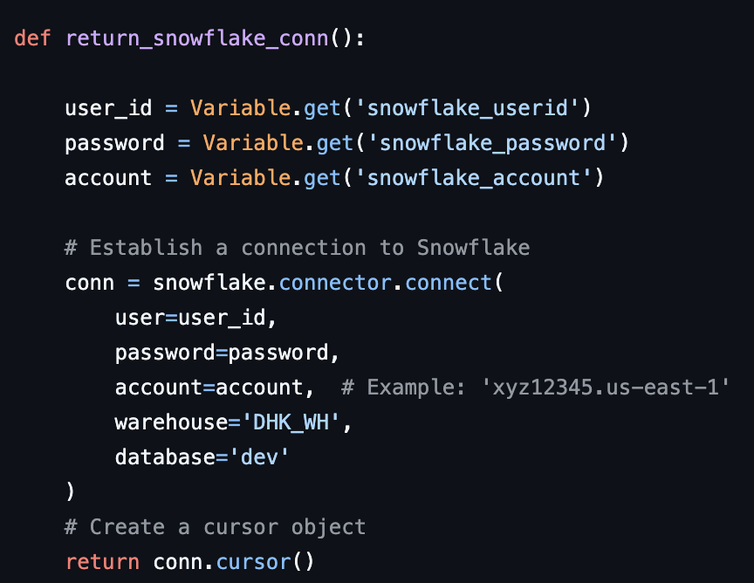

Fig. 1. Using Snowflake Connector to Connect to Snowflake

1. *Obtaining and Transforming Data*

With the Snowflake connector infrastructure in place, we can now proceed with the extraction and transformation phases of our ETL pipeline. To obtain stock data, we will utilize the yfinance API to retrieve historical stock data for the past 180 days. The yfinance library is particularly advantageous for data analysis, as it seamlessly integrates with Pandas, returning stock data in a DataFrame format. This is beneficial since SQL operates most efficiently with table-like structures. Additionally, yfinance offers flexible parameters that allow for easy customization of the data retrieval period. By setting the period parameter to 180 days, we can efficiently extract and analyze stock performance over the desired timeframe.

Fig. 2. Pandas DataFrame Returned Using yfinance

Although the raw data structure is nearly suitable for analysis, several adjustments are required before loading it into Snowflake. As shown in Figure 2, the yfinance download function returns a multi-indexed DataFrame, which could complicate analysis when imported into Snowflake. While it is essential to retain information about which stock each row corresponds to, it is more practical to store this detail as a separate column within the DataFrame. This ensures compatibility when importing data into a single Snowflake database, where information for multiple stocks will be stored together. SQL’s capabilities allow analysts to efficiently group and analyze the data for statistical modeling and forecasting as needed. Figure 3 illustrates the transformed DataFrame after these adjustments, demonstrating that the data is now properly structured and ready for storage in Snowflake.

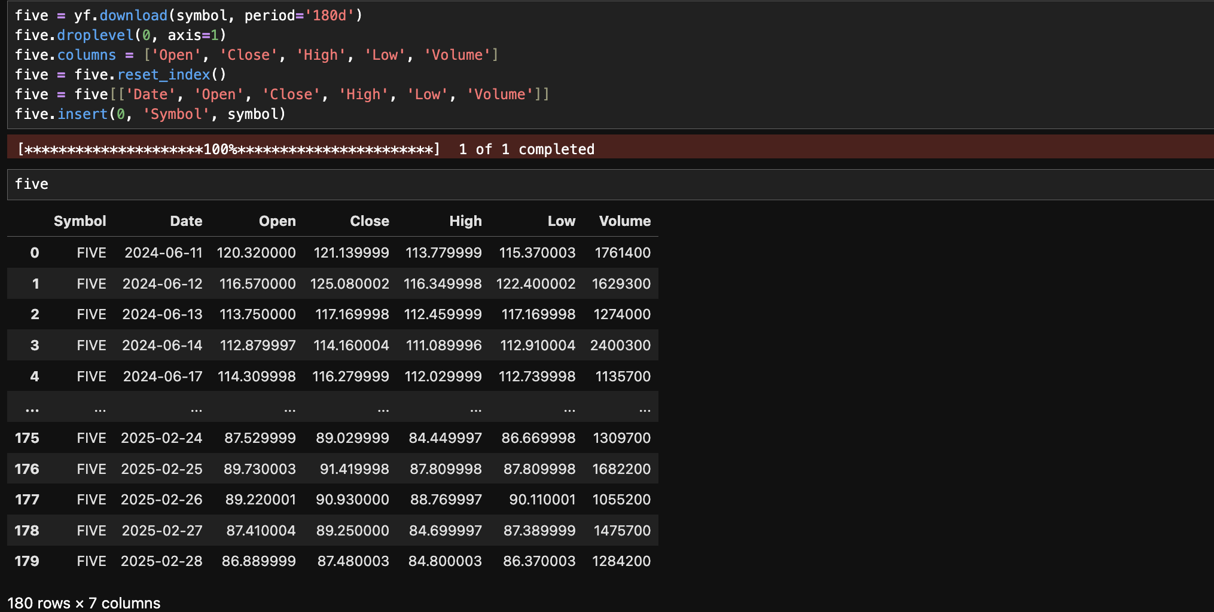

Fig. 3. Transforming DataFrame for Snowflake

1. *Loading Data into Snowflake*

With the tables properly formatted, the next step is to load the data into Snowflake. To establish a connection, we use either the snowflake.connector library or Apache Airflow’s SnowflakeHook, enabling seamless interaction with the database. The Snowflake database will be used to store historical data, while a view will be created to hold predicted values. Once predictions are generated, the view will be merged with the historical data to ensure the dataset remains up to date. Using a view in this structure provides two key benefits: it allows for efficient filtering based on stock symbols and ensures that predictive data remains separate from historical records, maintaining the integrity of the original table. The merging process follows Snowflake’s upsert (merge) method, ensuring data consistency by replacing existing values for matching keys while inserting new records. This approach preserves historical data while seamlessly integrating new predictions into the data warehouse.

To maintain data integrity, we will wrap the data loading process within SQL transactions, ensuring that all commands execute successfully before committing changes. If an error occurs at any point in the pipeline, the transaction will roll back the tables to their previous state, preventing corrupted or incomplete data from being inserted. This safeguards the final table from skewed results caused by programming or API failures. Additionally, when defining the table schema, we must ensure that the Date column is cast as a TIMESTAMP_NTZ type, as Snowflake’s forecasting functions require datetime-formatted data for proper analysis.

Fig. 4. Data Loaded into Snowflake

1. *Forecasting Stock Prices with Machine Learning*

With the data successfully loaded into Snowflake, we create two separate views based on the stock symbol—Apple (AAPL) and Five Below (FIVE). This separation is necessary because combining both stocks in a single forecast would result in predicting the average price of the two, which is more suitable for analyzing overall market trends rather than individual stock performance. While such an approach could be useful for broader industry-level analysis (e.g., comparing multiple tech stocks to assess market trends), our focus is on forecasting individual stock prices.

Since the stock symbol was stored as a separate column in the DataFrame, we can efficiently filter records using a WHERE clause in SQL to ensure that each view contains data for only one stock. Additionally, Snowflake’s forecasting function requires users to specify both a timestamp column and a target variable for analysis. Extracting and structuring these columns properly is essential to ensure the data is optimized for forecasting and predictive analytics.

Fig. 5. Forecasting Function using Connector

After creating the necessary views, we can utilize Snowflake’s built-in forecasting function to generate stock price predictions. By specifying the target column and timestamp, Snowflake automatically detects the data intervals within the DataFrame. Additionally, Snowflake applies multiple machine learning models to the dataset, selecting the most effective model internally. This automated approach eliminates the need for manual model selection and optimization, streamlining the forecasting process.

1. *Automating Pipeline and Predictions*

Now that we have the code and programs setup to make predictions on historical stock prices, we need to use Apache Airflow to automate the process of loading data into the table. In order to do so, we need to port our files into DAGS for Apache to run automatically, so we don’t need to manually run the program on a daily basis. In order to do so, we simply convert our functions into tasks by adding a decorator above the function declaration, and declare a DAG in which we are able to specify the order of operations in which the program executes. In our case, we will have one have two separate files. The first will be in charge of the ETL proess, and the second DAG will be in charge of creating predictions, and merging the predictions into the stock price database.

1. *ETL DAG*

In the ETL DAG, the program is scheduled to run once per day, as the API updates the stock’s closing price on a daily basis. Since the process involves retrieving data via an API call, transforming the data, and then storing the results in Snowflake, the tasks must be executed sequentially in this order for each stock.

1. *Stock Prediction DAG*

For the closing price prediction program, a separate DAG will be created to store the predicted values from the model, and merge those into the historical data table. The workflow consists of a task that creates a view to ensure the original table remains unchanged during predictions while allowing for filtering of the stock being analyzed, followed by a task that performs the prediction based on the closing stock price from the selected stock in the appropriate view. Since these operations must be executed sequentially, Apache Airflow’s bitshift operator (>>) will be used to ensure that model training runs first, followed by the prediction task, which depends on the model’s results.

After Apache Airflow’s Web UI performs a refresh, we are able to see the currently running DAGs on Airflow to ensure the DAGs loaded successfully into Airflow, and are ready for automation.

Fig. 6. Apache Airflow’s Web UI

Now that the tasks have been loaded into Apache Airflow, the system will automatically execute them once the specified cron condition is met. If the process completes successfully, the resulting table can be viewed. After reviewing the logs, we confirmed a successful run and were able to observe the program’s execution results.

Fig. 7. Table Showing Forecasted Values

Based on the SQL execution results, the query has successfully generated predictions for the closing stock price over the upcoming days and seamlessly merged them into the target table alongside historical values. This analysis allows for quick assessments of potential buying opportunities. For instance, as illustrated in Figure 7, the model forecasts a slight increase in Five Below’s stock price on the second predicted day, followed by a decline until March 13, when the price is expected to recover. Additionally, the model anticipates no significant movement in Apple’s stock price over the forecasted period. However, the widening gap between the lower and upper bounds—where the lower bound decreases while the upper bound rises—indicates increased price volatility.